Tent Area
Rigging Area
Rigging Area
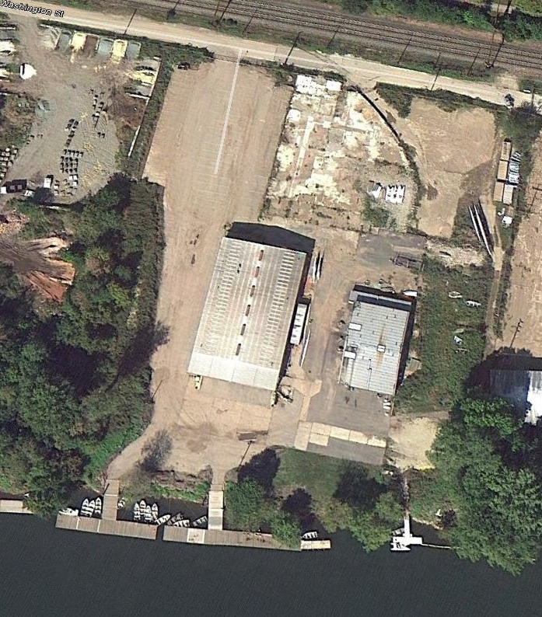
Tent Area
Shell trailers
(Back in)
Leave path open for teams to carry shells
Friends and Family
Parking Area
Washington Street
Hines Rowing Center
Mt. St. Joes
Boathouse

